John Hutchison

EDPS 742

Final Project

Investigating the Relationships Between Psychological Factors and Academic Performance in Students

**Introduction**

The mental health and well-being of students are crucial for their academic success and overall development. This study aims to explore the complex relationships between various psychological factors (such as anxiety, self-esteem, and depression), stress levels, and academic performance. By understanding these relationships, educational institutions can develop better support systems to enhance student well-being and academic outcomes.

Research Questions:

1. How do psychological factors (anxiety level, self-esteem, and depression) relate to academic performance and stress levels in students?
2. What are the key predictors of stress levels among students?

Hypotheses:

1. There is a significant negative correlation between anxiety levels and academic performance.
2. Higher levels of self-esteem are associated with better academic performance and lower stress levels.

References:

Duckworth, A. L., & Seligman, M. E. P. (2005). Self-Discipline Outdoes IQ in Predicting Academic Performance of Adolescents. Psychological Science, 16(12), 939-944.

* This study demonstrates that self-discipline is a stronger predictor of academic performance than IQ, emphasizing the role of self-regulation and psychological factors. This supports the examination of self-esteem and other psychological variables as important predictors of academic success.

Kappe, R., & van der Flier, H. (2012). Predicting academic success in higher education: What's more important than being smart? European Journal of Personality, 26(4), 451-462.

* This study investigates the predictors of academic success beyond intelligence, emphasizing the role of personality traits and motivational factors. It highlights the importance of non-cognitive factors such as self-esteem and anxiety in academic performance, aligning with the research focus.

Pascoe, M. C., Hetrick, S. E., & Parker, A. G. (2020). The impact of stress on students in secondary school and higher education. International Journal of Adolescence and Youth, 25(1), 104-112.

* This review examines the effects of stress on secondary and higher education students, identifying key stressors and their impact on mental health and academic performance. It provides insights into the relationship between stress levels and academic outcomes, supporting the investigation of stress predictors in the dataset.

Sander, P., & Sanders, L. (2006). Understanding academic confidence. Psychology Teaching Review, 12(1), 29-39.

* This paper investigates the concept of academic confidence and its relationship with academic performance, supporting the further exploration of psychological factors like self-esteem and their influence on academic outcomes.

**Methods**

Research Design:

This study utilizes a correlational research design to explore the relationships between psychological factors and academic performance among students. The dataset includes various indicators related to these domains, allowing for a comprehensive analysis of the factors influencing academic success and stress levels.

Participants:

The sample for this study consisted of 1,100 students drawn from a diverse range of high schools and universities within Dharan, Nepal. The participants included a balanced representation of genders, with 53% male and 47% female students. The age of the participants ranged from 15 to 22 years, with a mean age of 18.5 years.

Survey Description:

The survey used for this study was a comprehensive, self-administered questionnaire designed to gather detailed information on various psychological factors, health behaviors, environmental conditions, and academic performance among students. The psychological factors section included validated scales to measure anxiety levels, self-esteem, mental health history, and symptoms of depression and headaches. The health behaviors section collected data on blood pressure, sleep quality, and breathing problems, using standardized self-report items. Environmental conditions were assessed through questions on noise levels, living conditions, safety, and basic needs satisfaction. Academic and social factors were captured through items on study load, teacher-student relationships, future career concerns, social support, peer pressure, extracurricular activities, and experiences of bullying. Each item was measured on a Likert scale, ensuring consistency and ease of response.

Data Analysis:

Initially, descriptive statistics were calculated for each variable to understand the basic characteristics of the data, including mean, median, standard deviation, and range. This provided a clear overview of the data distribution and highlighted any potential outliers or anomalies.

Following this, a canonical correlation analysis (CCA) was conducted to explore the multivariate relationships between two sets of variables. The first set included psychological factors: anxiety level, self-esteem, and depression. The second set included academic performance and stress levels. This analysis provided initial insights into how a combination of psychological factors relate to academic and stress outcomes.

Lastly, to further investigate these relationships, multiple regression analyses were performed. These analyses aimed to identify key predictors of academic performance and stress levels by regressing these outcomes on the set of independent variables. This helped to pinpoint which factors had the most substantial impact on students' academic success and stress levels.

**Results**

Descriptive Statistics:

Table 1 displays the descriptive statistics for the variables under study, highlighting their central tendencies and variability. All the variables exhibited relatively low skew and kurtosis, indicating normal behavior. This is further evidenced by their histograms in Figures 1-5.

Table 1: Descriptive Statistics

Figure 1: Anxiety level histogram

Figure 2: Self-esteem histogram

Figure 3: Depression histogram

Figure 4: Academic performance histogram

Figure 5: Stress level histogram

Canonical Correlation Analysis (CCA):

Tables 2-10 present the key results of the canonical correlation analysis, including the canonical correlations, squared correlations, canonical loadings, cross loadings, variance extracted, redundancy, and interpretation of the canonical functions.

Table 2: Canonical Correlations and Wilks' Lambda

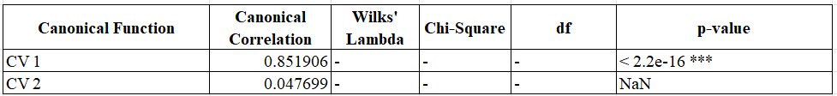

Table 3: Squared Canonical Correlations

Table 4: Canonical Loadings for Set 1 (Psychological Factors)

Table 5: Canonical Loadings for Set 2 (Academic and Health Indicators)

Table 6: Cross Loadings for Set 1 (Psychological Factors)

Table 7: Cross Loadings for Set 2 (Academic and Health Indicators)

Table 8: Variance Extracted and Redundancy

Table 9: Canonical Variate Adequacy

The CCA revealed two canonical functions, with the first canonical function showing a strong canonical correlation (CV 1 = 0.851906) and the second function showing a very weak correlation (CV 2 = 0.047699). The squared canonical correlations for the first and second functions were 0.725744 and 0.002275, respectively, indicating that the first function accounts for a significant portion of the shared variance between the sets of variables, while the second function does not. Variance extracted and redundancy indices for the first canonical function were substantial (Set 1 Variance Extracted = 0.574411, Set 2 Variance Extracted = 0.607398), indicating a significant proportion of variance explained by the canonical variates.

The first canonical function demonstrates significant multivariate relationships between the psychological factors and the academic/health indicators. Higher anxiety and depression levels are associated with lower academic performance and higher stress levels, while higher self-esteem is associated with better academic performance and lower stress. The second canonical function does not provide meaningful insights due to its weak correlation and lack of significance.

Regression:

Table 10 shows the ANOVA table for the multivariate regression model. All the independent variables (anxiety level, self-esteem, and depression) are significant predictors of both academic performance and stress level, with p-values less than 0.001, indicating strong evidence against the null hypothesis for each predictor.

Table 10: Analysis of Variance (ANOVA) Table

The regression analysis for academic performance reveals that higher anxiety levels and depression are associated with lower academic performance, while higher self-esteem is associated with better academic performance. The multiple R-squared value of 0.5187 indicates that approximately 51.87% of the variance in academic performance is explained by these three psychological factors.

Table 11: Regression Summary for Academic Performance

Similarly, the regression analysis for stress levels indicates that higher anxiety and depression levels are associated with higher stress levels, while higher self-esteem is associated with lower stress levels. The multiple R-squared value of 0.6969 indicates that approximately 69.69% of the variance in stress levels is explained by these psychological factors.

Table 12: Regression Summary for Stress Level

Assumptions:

The assumptions for CCA and multivariate regression are as follows:

* Linearity: Based on the matrix scatter plot, it can be assumed that the relationships are approximately linear.

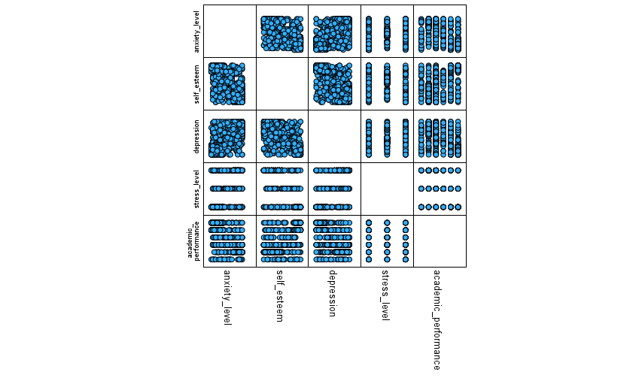

Figure 6: Matrix scatter plot

* Multivariate Normality: Based on the variable histograms, it is assumed that the variables follow a normal distribution.
* Homogeneity of Variances: This analysis did not explicitly test for homoscedasticity. Future studies should include this test to validate the assumption.
* Multicollinearity: The VIF values suggest low multicollinearity.

Table 13: Academic performance regression table to show collinearity statistics

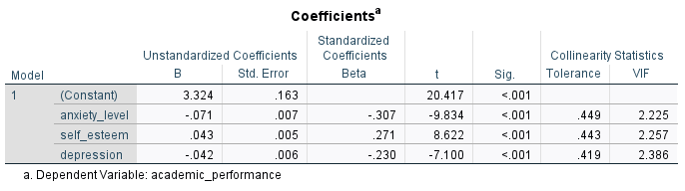

**Discussion**

This study aimed to explore the relationships between psychological factors (anxiety level, self-esteem, depression), stress levels, and academic performance among students. Both the CCA and the regression analyses revealed that higher anxiety and depression levels were associated with lower academic performance and higher stress levels, while higher self-esteem was associated with better academic performance and lower stress levels. These results were statistically significant with a strong effect size.

These findings align with previous research that highlights the significant impact of psychological factors on academic performance and stress levels. Studies by Duckworth and Seligman (2005) and Pascoe et al. (2020) have shown that anxiety and depression negatively affect academic outcomes and increase stress, while self-esteem and self-discipline positively influence academic performance and reduce stress.

The results of this study are valuable because they demonstrate the need for enhanced mental health support for students. The findings provide evidence for institutional staff and policymakers making data-driven decisions. Hopefully the results of this and related studies will persuade them to incorporate more mental health resources and education within schools.

It is important to note that the study's findings are limited by the quality and completeness of the dataset. Future research should consider longitudinal designs to establish causal relationships between psychological factors and academic outcomes. Additionally, exploring other potential moderating variables, such as social support and extracurricular activities, could provide a more comprehensive understanding of the factors influencing student well-being and academic success.